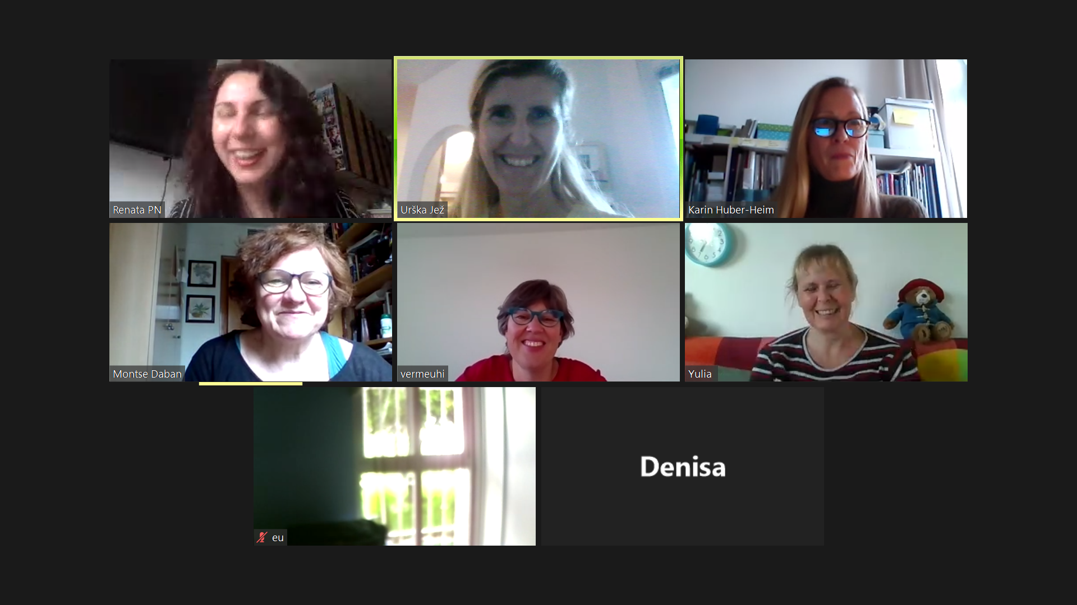

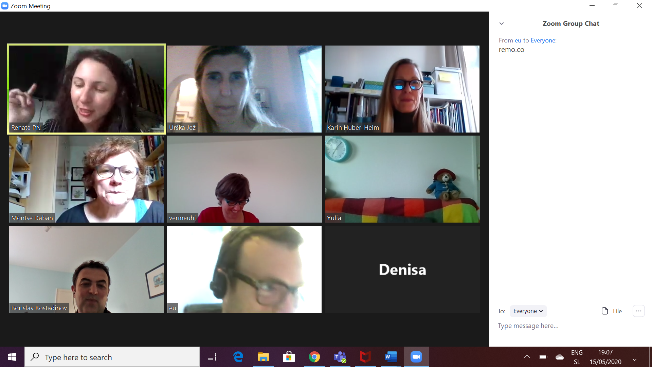

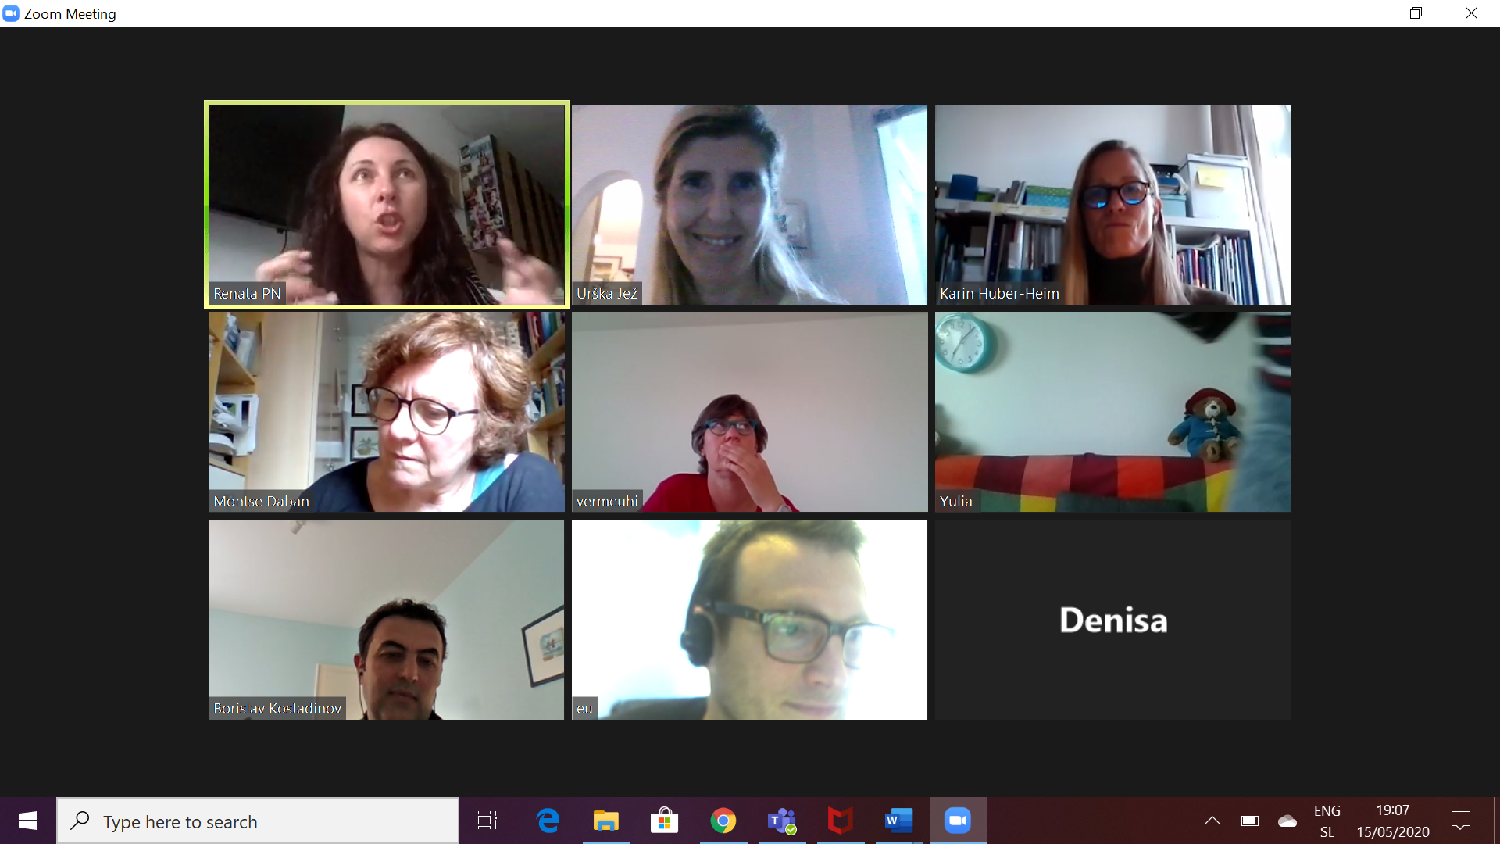

From Me to Everyone: 07:09 PM
realtime dashboard to detect what the missing (not met needs from teams are - Eugenio has 1 Phd student that could help
Eureka - to evaluate projects
From eu to Everyone: 07:09 PM
https://www.eurostars-eureka.eu/eurostars-expert-area

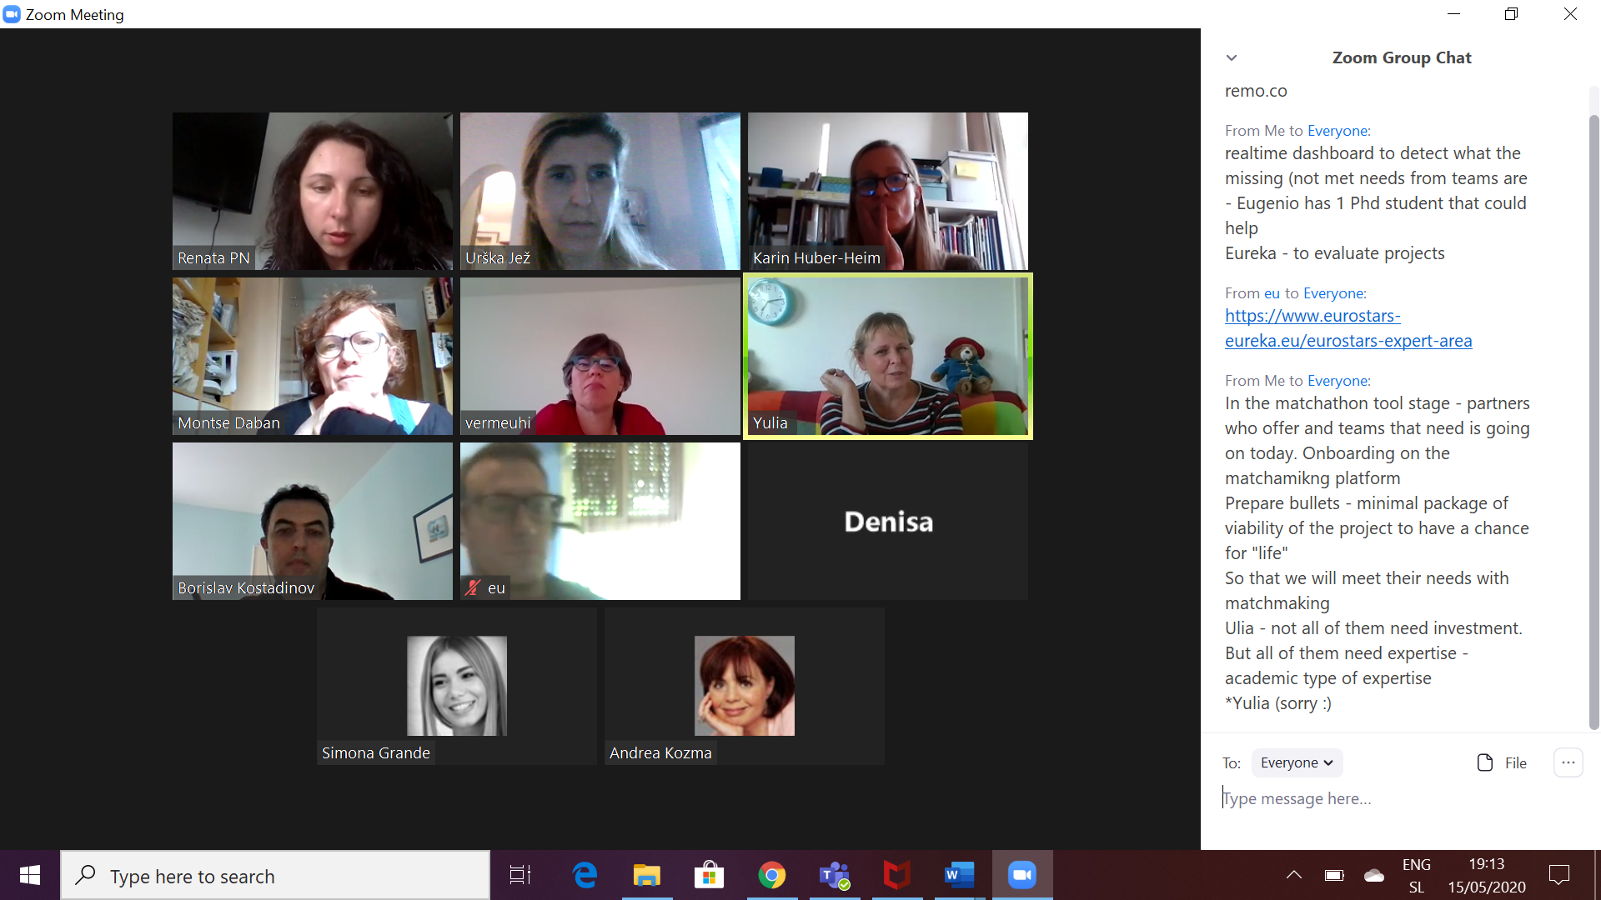

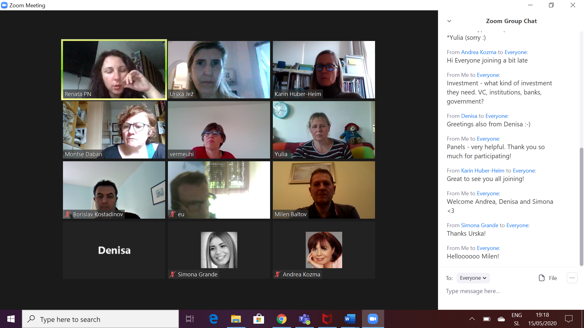

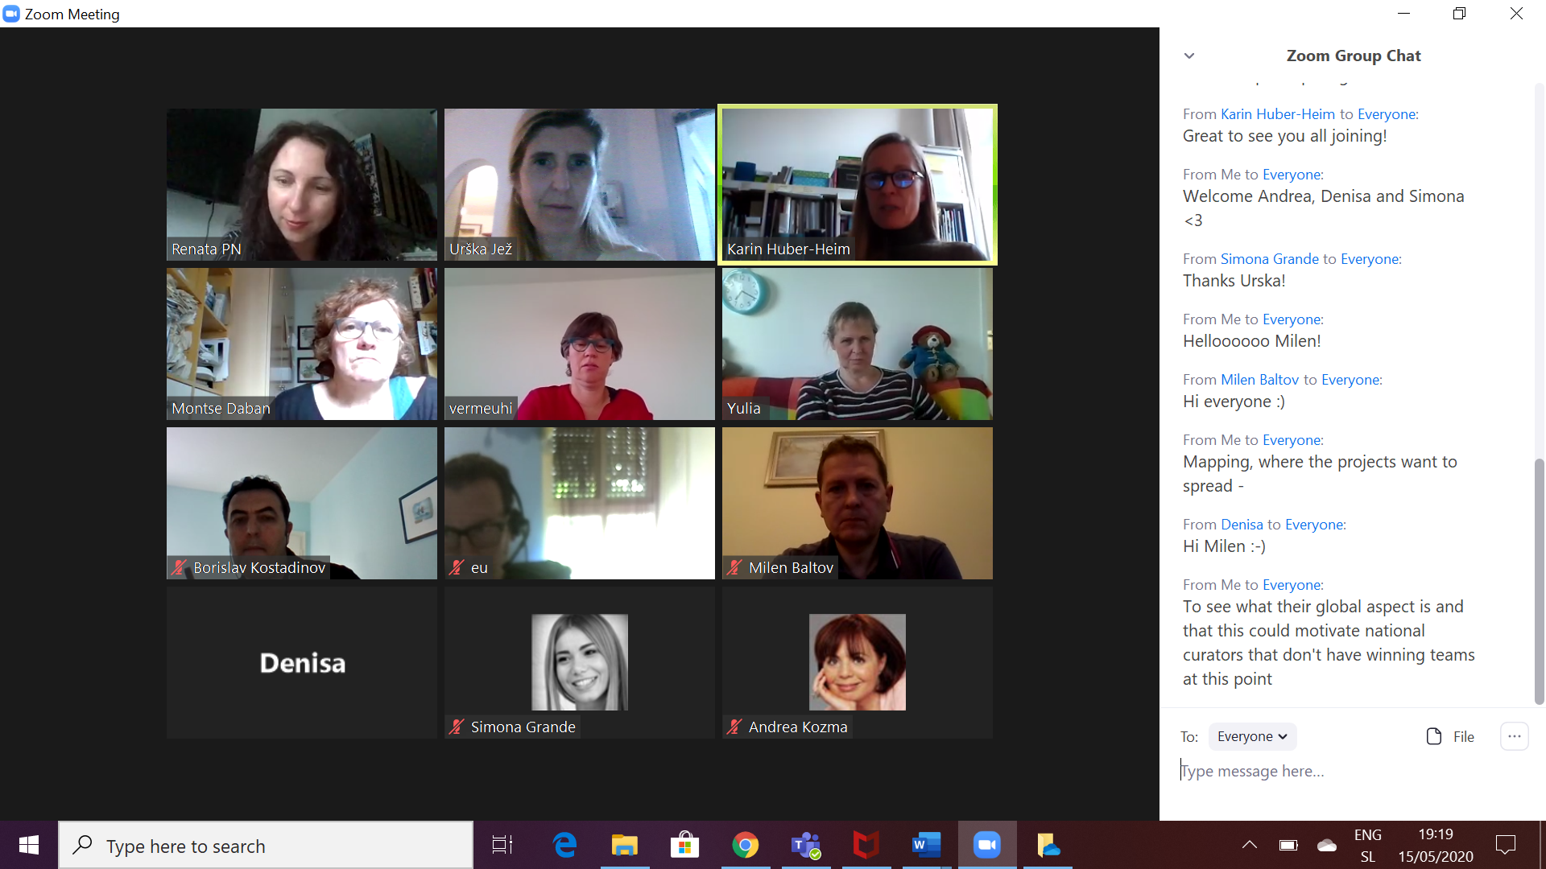
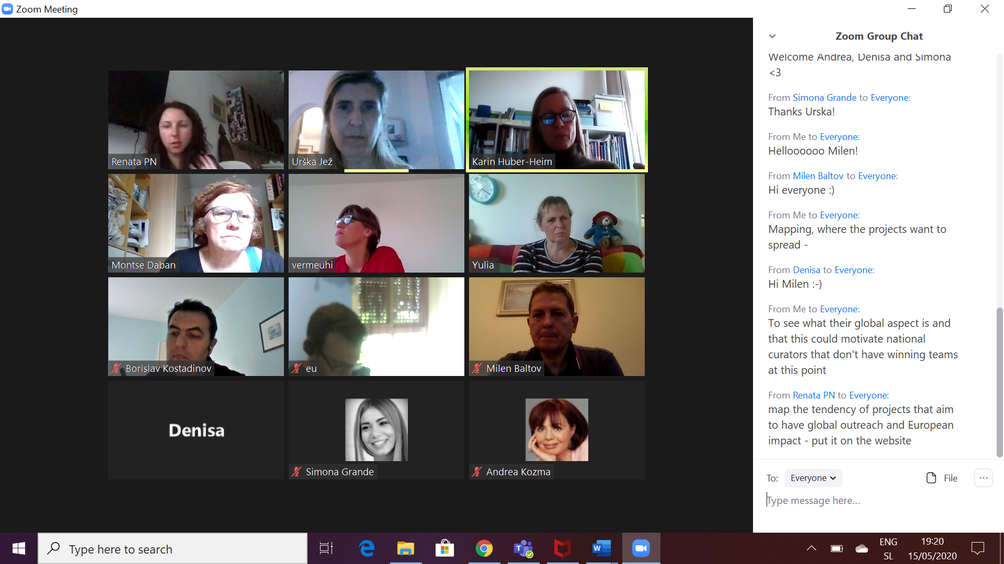

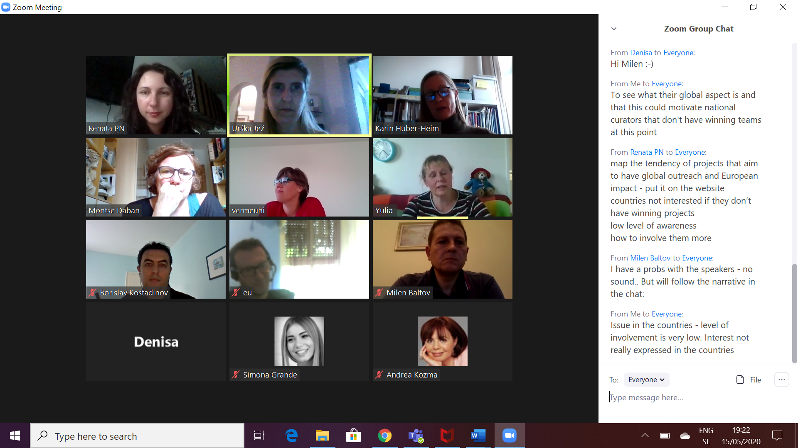

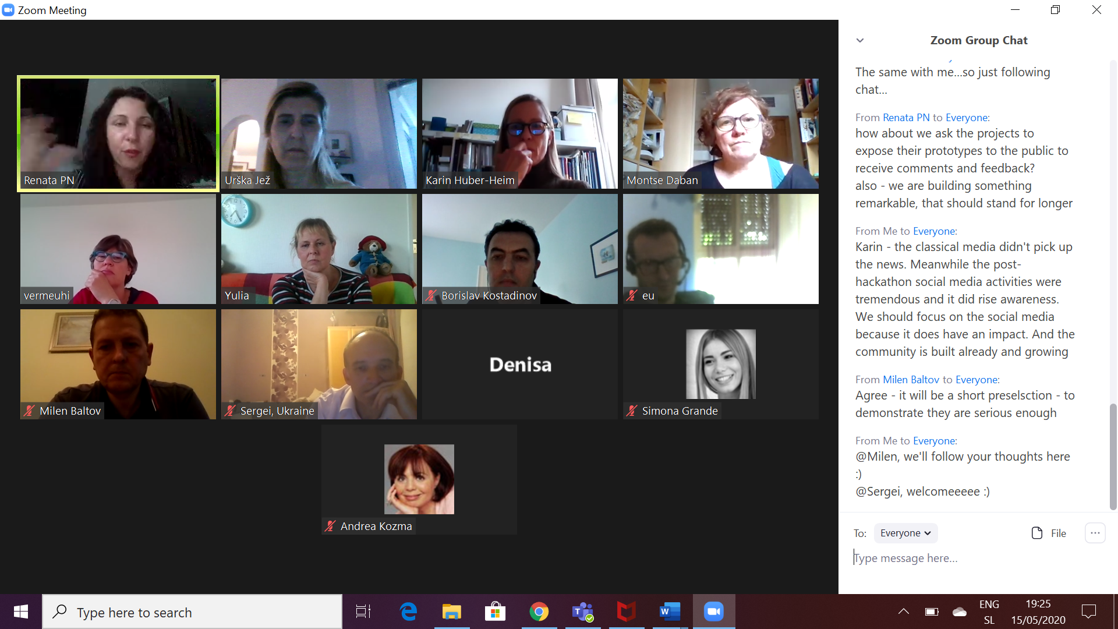

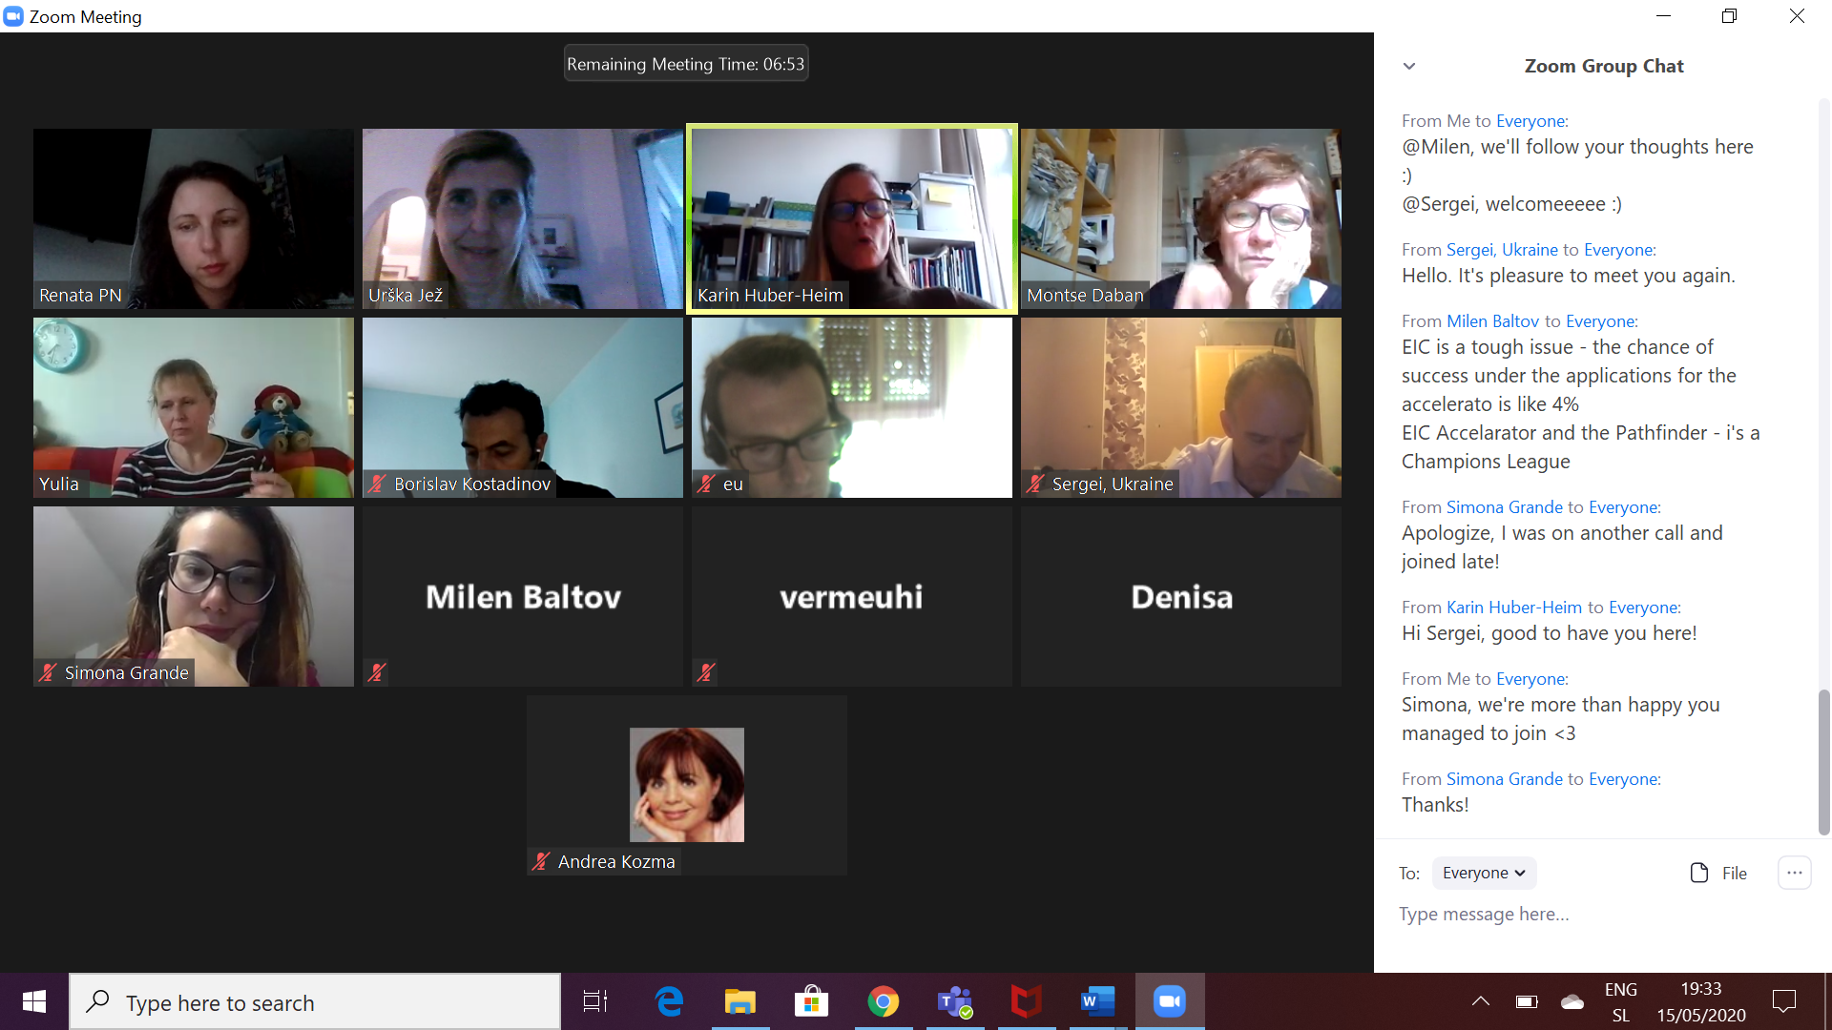

From eu to Everyone: 07:05 PM
remo.co
From Me to Everyone: 07:09 PM
realtime dashboard to detect what the missing (not met needs from teams are - Eugenio has 1 Phd student that could help
Eureka - to evaluate projects
From eu to Everyone: 07:09 PM
https://www.eurostars-eureka.eu/eurostars-expert-area
From Me to Everyone: 07:13 PM
In the matchathon tool stage - partners who offer and teams that need is going on today. Onboarding on the matchamikng platform
Prepare bullets - minimal package of viability of the project to have a chance for "life"
So that we will meet their needs with matchmaking
Ulia - not all of them need investment. But all of them need expertise - academic type of expertise
*Yulia (sorry :)
From Andrea Kozma to Everyone: 07:13 PM
Hi Everyone joining a bit late
From Me to Everyone: 07:14 PM
Investment - what kind of investment they need. VC, institutions, banks, government?
From Denisa to Everyone: 07:15 PM
Greetings also from Denisa :-)
From Me to Everyone: 07:15 PM
Panels - very helpful. Thank you so much for participating!
From Karin Huber-Heim to Everyone: 07:15 PM
Great to see you all joining!
From Me to Everyone: 07:15 PM
Welcome Andrea, Denisa and Simona <3
From Simona Grande to Everyone: 07:17 PM
Thanks Urska!
From Me to Everyone: 07:18 PM
Helloooooo Milen!
From Milen Baltov to Everyone: 07:18 PM
Hi everyone :)
From Me to Everyone: 07:18 PM
Mapping, where the projects want to spread -
From Denisa to Everyone: 07:19 PM
Hi Milen :-)
From Me to Everyone: 07:19 PM
To see what their global aspect is and that this could motivate national curators that don't have winning teams at this point
From Renata PN to Everyone: 07:21 PM
map the tendency of projects that aim to have global outreach and European impact - put it on the website
countries not interested if they don’t have winning projects
low level of awareness
how to involve them more
From Milen Baltov to Everyone: 07:21 PM
I have a probs with the speakers - no sound.. But will follow the narrative in the chat:
From Me to Everyone: 07:21 PM
Issue in the countries - level of involvement is very low. Interest not really expressed in the countries
From Denisa to Everyone: 07:23 PM
The same with me...so just following chat...
From Renata PN to Everyone: 07:24 PM
how about we ask the projects to expose their prototypes to the public to receive comments and feedback?
also - we are building something remarkable, that should stand for longer
From Me to Everyone: 07:24 PM
Karin - the classical media didn't pick up the news. Meanwhile the post-hackathon social media activities were tremendous and it did rise awareness. We should focus on the social media because it does have an impact. And the community is built already and growing
From Milen Baltov to Everyone: 07:25 PM
Agree - it will be a short preselsction - to demonstrate they are serious enough
From Me to Everyone: 07:25 PM
@Milen, we'll follow your thoughts here :)
@Sergei, welcomeeeee :)
From Sergei, Ukraine to Everyone: 07:26 PM
Hello. It's pleasure to meet you again.
From Milen Baltov to Everyone: 07:27 PM
EIC is a tough issue - the chance of success under the applications for the accelerato is like 4%
EIC Accelarator and the Pathfinder - i's a Champions League
From Simona Grande to Everyone: 07:28 PM
Apologize, I was on another call and joined late!
From Karin Huber-Heim to Everyone: 07:28 PM
Hi Sergei, good to have you here!
From Me to Everyone: 07:28 PM
Simona, we're more than happy you managed to join <3
From Simona Grande to Everyone: 07:28 PM
Thanks!
From Me to Everyone: 07:37 PM
Researchers expressed their wish and potential to follow and publish all sorts of topics/content from the hachathon and matchathon.

